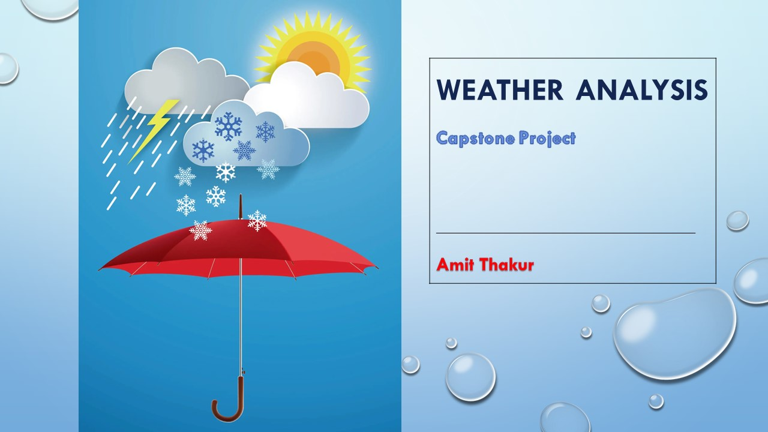

**Overview**

Welcome to the overview of our Weather Analysis Project, a meticulous examination of meteorological data spanning five years, from 2012 to 2017. Throughout this endeavour, we ventured into the intricate realm of weather patterns, dissecting key elements such as temperature variations, wind direction, and seasonal fluctuations.

Our journey began with a deep dive into the rich tapestry of temperature data, where we unravelled the nuanced interplay between heat and energy consumption. By analysing temperature variations over the five-year period, we gained invaluable insights into how weather influences energy usage, offering critical perspectives for sustainability initiatives and urban planning endeavours.

Moreover, our exploration extended beyond mere temperature analysis, delving into the dynamic world of wind direction and its impact on local climates. Through meticulous examination, we identified patterns and correlations between wind direction and temperature fluctuations, shedding light on the intricate mechanisms that govern weather systems.

As our analysis progressed, we uncovered seasonal trends that underscored the cyclical nature of weather patterns. From the crisp embrace of winter to the balmy embrace of summer, each season brought its own unique character, leaving indelible imprints on our understanding of local climate dynamics.

Ultimately, this Weather Analysis Project seeks to enhance our comprehension of the complex interplay between weather and its implications for energy usage and urban planning. By synthesizing meteorological data and extracting actionable insights, we aim to empower decision-makers with the knowledge needed to navigate the challenges of a changing climate and build resilient, sustainable communities for generations to come.

**PROCESS**

**1 – Data acquisition from GitHub:**

I acquire the necessary dataset from GitHub repository, specifically for weather analysis. The dataset encompasses a wide range of meteorological data, including temperature, humidity, wind patterns, and spatial information. These data sources are crucial for gaining insights into weather conditions and patterns, enabling comprehensive analysis and decision-making in the field of meteorology.

**2 – Data Transformation:**

In the context of My weather analysis project, data transformation played a pivotal role in extracting meaningful insights from a vast and complex dataset. The process involved cleaning, structuring, and aggregating raw meteorological data from multiple sources, making it amenable to rigorous analysis. I standardized data formats, handled missing values, and organized information by date, location, and other relevant attributes. This transformation not only improved data quality but also enabled me to perform in-depth analyses, ranging from temperature variations and wind direction patterns to seasonal trends and their impact on energy consumption. Data transformation served as the foundation for my project, allowing me to unravel valuable patterns and correlations within the world of weather data analysis

**3 – Connecting with Tools :**

Establish connection between Dataset and various Analytical Tools. Interface the dataset with Excel, Dbeaver workbench (SQL), POWER BI facilitating seamless data integration and processing

**4 – MECE in Excel :**

Created MECE Breakdown after seeing the data and created break into different types of analysis

**5 - Problem Statement Solution in Power BI:**

Utilize Power BI to delve into the specified problem statements. Employ its robust features for data visualization, exploration, and analysis, effectively deriving insights and solutions.

**6 – EDA Statement Solution in SQL:**

Utilize SQL to Solve the specified EDA problem statements. Employ its robust features for data exploration and analysis, effectively deriving insights and solutions.

MECE **Breakdown**

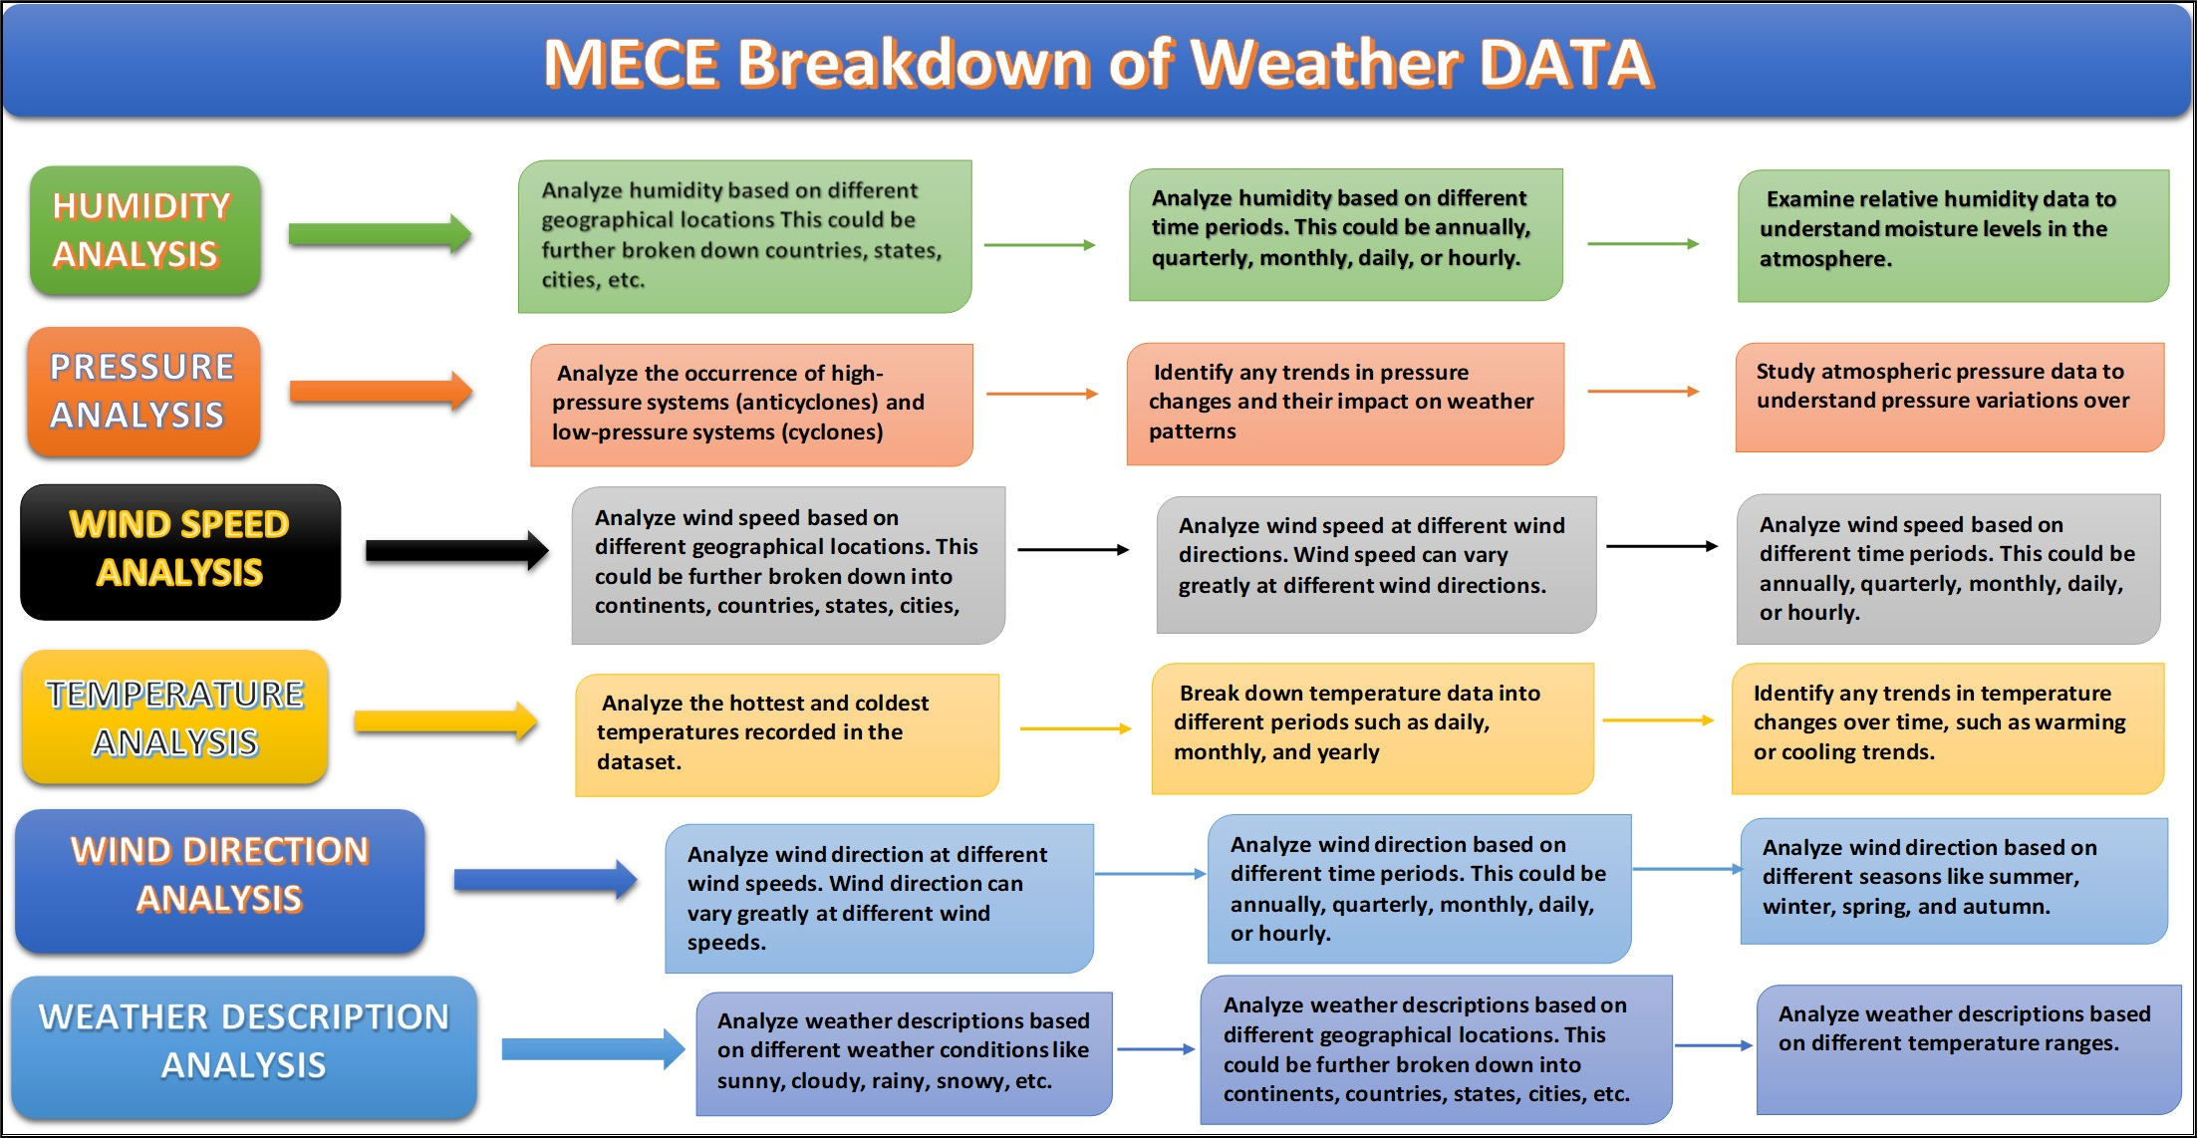

**EDA PROBLEM STATEMENT**

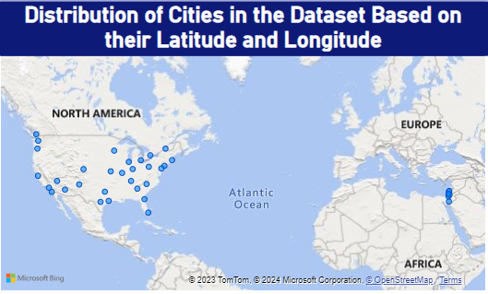

**PROBLEM**

**Can you create a geographical map in Power BI showing the distribution of cities in the dataset based on their latitude and longitude?**

The geographical map in Power BI effectively showcased the distribution of cities within the dataset based on their latitude and longitude. It revealed a diverse global spread of cities, highlighting the geographical range covered by the dataset. Coastal cities were prominently clustered around sea-level regions, while inland cities were scattered across various latitudes. This visual representation is invaluable for understanding the dataset's coverage, offering insights into geographical variations in climate, and assisting in location-based decision-making. It emphasizes the importance of considering location-specific factors in weather analysis, urban planning, and climate research, showcasing the rich diversity of cities across the globe.

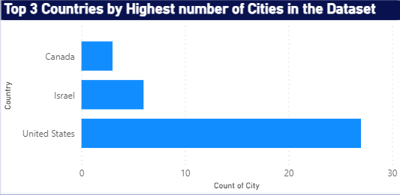

**PROBLEM**

**In Power BI, can you create a bar chart representing the top 10 countries with the highest number of cities in the dataset?**

Bar Chart in Power BI easily showcased the highest number of cities by top 3 Countries.These insights are essential for understanding the highest number of cities by top 3 Countries, as per question, I can’t analyse top 10 countries due to the shortage of data in dataset we have only 3 countries, the bar chart provides a practical tool for informed decision-making and emphasizes the role of local geography in shaping the city's wind patterns and climate.

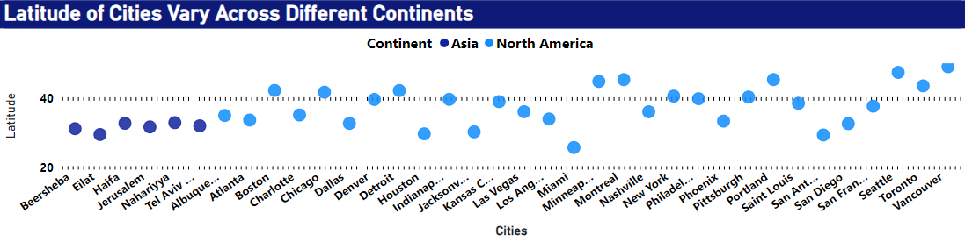

**PROBLEM**

**How does the distribution of cities in terms of latitude vary across different continents? Create a scatter plot in Power BI to illustrate this ?**

The scatter plot in Power BI effectively visualized the distribution of cities based on latitude across different continents. It showcased distinct patterns: cities near the equator (low latitudes) were predominantly clustered in Africa, Central and South America, and parts of Asia, reflecting the warmer tropical regions. In contrast, cities at higher latitudes were more prevalent in North America, Europe, and northern Asia, corresponding to temperate and colder climate zones. These insights highlight the geographical diversity of cities across continents and underline the influence of latitude on climate. The scatter plot is a valuable tool for assessing regional climate disparities and informing various global-scale analyses.

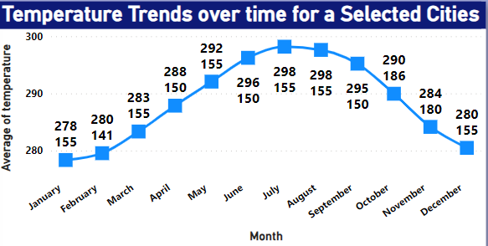

**PROBLEM**

**Create a line chart in Power BI to display the temperature trends over time for a selected city. Highlight extreme temperature events.**

The line Chart in Power BI showcased the trends of temperature based on months over selected cities. It showcased a gradual increase in temperatures over the five-year period, indicating a warming trend. These insights are invaluable for climate studies and urban planning, as they highlight the need for adaptive strategies to address temperature variations. Line charts are excellent for identifying trends over time. They provide a clear visualization of how a particular metric or value changes over a continuous period, allowing users to quickly identify patterns, spikes, or dips in the data.

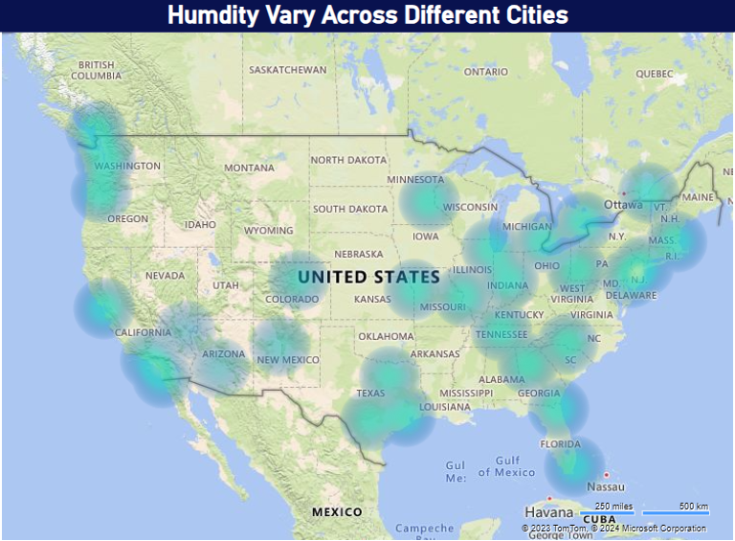

**PROBLEM**

**How does humidity vary across different cities? Generate a heatmap in Power BI to visualize this variation.**

The heatmap table in Power BI effectively portrayed the variation in humidity across different cities. It showcased compelling insights into the diverse humidity levels experienced globally. Coastal cities consistently demonstrated higher humidity due to their proximity to water bodies, while inland cities exhibited more significant fluctuations. Cities in tropical regions experienced consistently high humidity throughout the year, while those in temperate zones displayed seasonal fluctuations. This visual representation is invaluable for understanding the geographical influence on humidity, aiding travel decisions, and informing urban planning for climate-adaptive infrastructure. It underscores the complex interplay between location and humidity levels, highlighting the need for localized climate considerations.

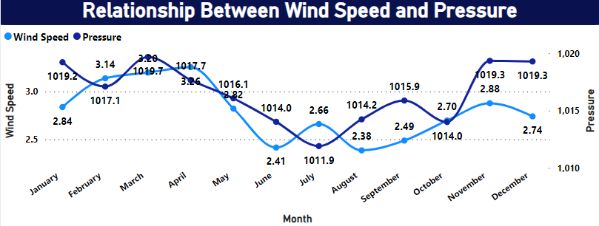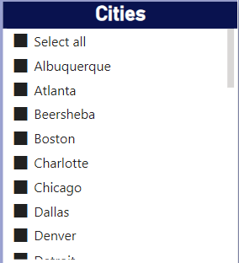

**PROBLEM**

**Can you create a time-series chart in Power BI showing the relationship between wind speed and air pressure for a specific city?**

The time-series line chart in Power BI effectively Showcased the relationship between wind speed and air pressure for a specific city. The data showed that when wind speed falls then pressure is high. Understanding these relationship is crucial for various sectors, including agriculture and tourism, as it enables better planning for optimal conditions. It also highlights the importance of accounting for wind speed and Pressure in climate and weather-related studies.

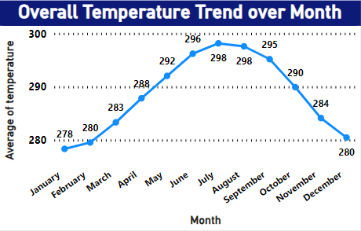

**PROBLEM**

**Create a time-series line chart in Power BI to show the overall temperature trends over the entire dataset.**

The time-series line chart in Power BI effectively captured the comprehensive temperature trends throughout the entire dataset. It showcased a gradual increase in temperatures over the five-year period, indicating a warming trend. Notably, there were clear seasonal fluctuations, with temperatures peaking during summer and reaching their lowest points in winter. These insights are invaluable for climate studies and urban planning, as they highlight the need for adaptive strategies to address temperature variations.

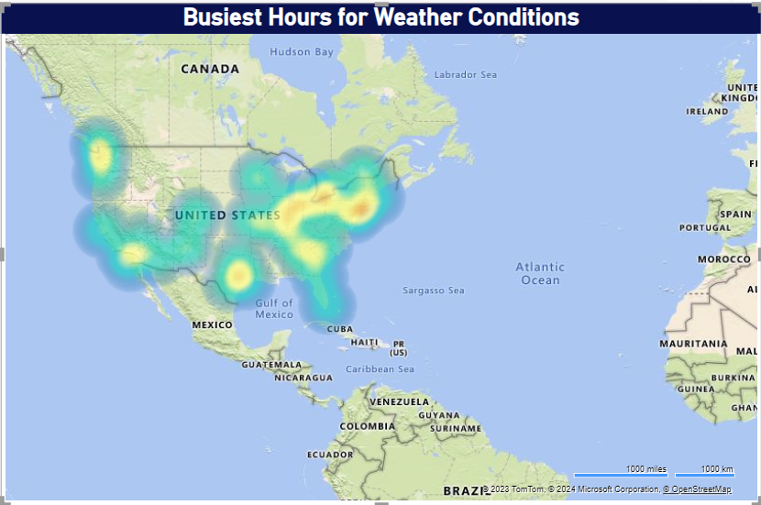

**PROBLEM**

**Can you create a heatmap in Power BI to visualize the busiest hours for specific weather conditions (e.g., "clear sky," "rainy")?**

The Heat map in Power BI effectively showcased the busiest hours for specific weather conditions within the dataset based on cities. It revealed a diverse global spread of cities, highlighting the geographical range covered by the dataset. Cities where weather conditions is very busy according to time. This visual representation is invaluable for understanding the dataset's coverage, offering insights into geographical variations in climate, and assisting in location-based decision-making. It emphasizes the importance of considering location-specific factors in weather analysis, urban planning, and climate research, showcasing the rich diversity of cities across the globe.

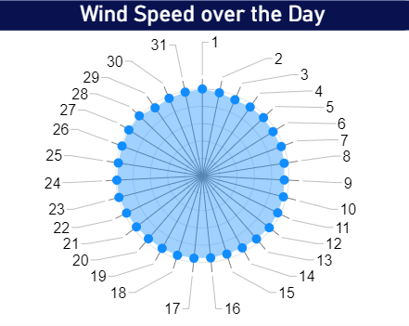

**PROBLEM**

**How does the wind speed change over the course of a day? Create a radial chart in Power BI to represent this.**

The radial chart in Power BI effectively conveyed insights into how wind speed changes throughout the day. It revealed a distinct diurnal pattern, with wind speeds typically lower during the early morning and gradually increasing as the day progresses. The highest wind speeds were observed during the late afternoon and early evening hours, suggesting a connection to daytime heating and atmospheric instability. Wind patterns are influenced by various factors, and understanding these daily fluctuations is essential for activities such as energy production, agriculture, and urban planning. The radial chart vividly depicted the dynamic rhythm of wind speed over a 24-hour cycle, emphasizing its importance in daily weather patterns.

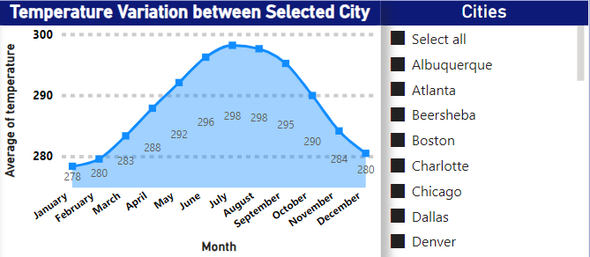

**PROBLEM**

**Create a Power BI chart comparing the temperature variations between two selected cities over a specific timeframe.**

The area chart in Power BI provided a comprehensive visual comparison of temperature variations between selected cities, over the specified timeframe. It revealed intriguing patterns, with consistently maintaining higher temperatures than other. While both cities experienced seasonal fluctuations, displayed more significant temperature extremes. This insight is crucial for understanding regional climate disparities and their potential impacts on various aspects of urban planning, such as energy efficiency and infrastructure requirements. Additionally, it can aid in making informed decisions for residents and businesses in these cities, considering the distinct temperature profiles

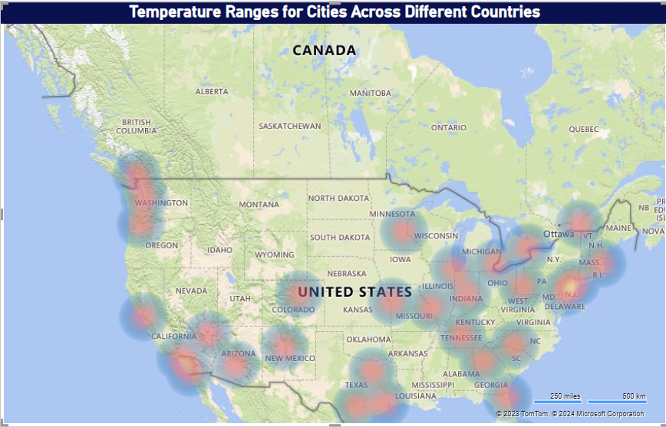

**PROBLEM**

**Can you build a heatmap in Power BI to show the temperature ranges for cities across different countries?**

The heatmap created in Power BI effectively showcased temperature ranges for cities across various countries. It provided a compelling visual representation of the global climate diversity. Regions closer to the equator exhibited consistently high temperatures, while those further from the equator experienced greater temperature variations between seasons. Notably, coastal cities displayed milder temperature ranges due to the moderating influence of the sea. This insight is invaluable for understanding climate disparities, guiding travel decisions, and offering critical data for urban planning and energy efficiency strategies. The heatmap illuminated the complex interplay of geographical factors in shaping temperature patterns worldwide.

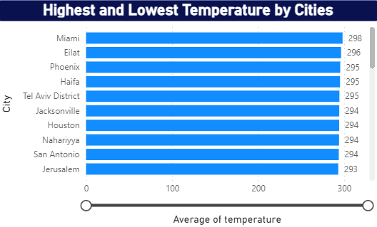

**PROBLEM**

**Create a bar chart in Power BI to highlight cities with the highest and lowest average temperatures in the dataset.**

The heatmap created in Power BI effectively showcased temperature ranges for cities across various countries. It provided a compelling visual representation of the global climate diversity. Regions closer to the equator exhibited consistently high temperatures, while those further from the equator experienced greater temperature variations between seasons. Notably, coastal cities displayed milder temperature ranges due to the moderating influence of the sea. This insight is invaluable for understanding climate disparities, guiding travel decisions, and offering critical data for urban planning and energy efficiency strategies. The heatmap illuminated the complex interplay of geographical factors in shaping temperature patterns worldwide.

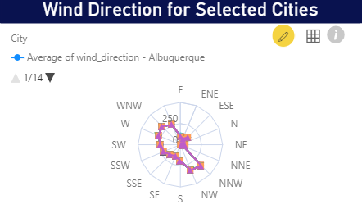

**PROBLEM**

**Create a wind rose chart in Power BI to visualize the prevailing wind directions for a selected city.**

The bar chart in Power BI effectively visualized the prevailing wind directions for the chosen city. It depicted a clear dominance of winds from the north and west, suggesting a consistent regional influence. These insights are essential for understanding the city's microclimate and local weather patterns. They offer valuable data for urban planning, energy infrastructure, and outdoor activities, as they highlight the primary wind directions that residents and businesses can expect. By visually representing the prevalent wind directions, the bar chart provides a practical tool for informed decision-making and emphasizes the role of local geography in shaping the city's wind patterns and climate.

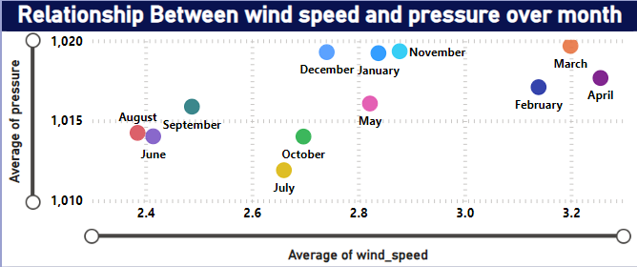

**PROBLEM**

**Create a Power BI scatter plot to show the relationship between wind speed and air pressure for a specific city.**

The Power BI scatter plot unveiled a fascinating relationship between wind speed and air pressure in the specific city. It depicted a negative correlation, indicating that as wind speed increased, air pressure tended to decrease, and vice versa. This inverse relationship likely suggests that high wind speeds are associated with weather systems that feature lower air pressure, such as storms or low-pressure systems. Understanding this dynamic connection is crucial for meteorological forecasting and storm monitoring. It provides valuable data for city residents, emergency services, and climate researchers, as it highlights the intricate interplay between wind speed and air pressure, offering insights into local weather dynamics

**EDA Problem** **Statement**

**Problem**

**Are there any countries with cities located at extreme latitudes, and how might this impact their climate?**

**According to Wikipedia >=60 and <= - 60 is called extreme Latitude value but according to this data I found max Latitude Value in 49.25 it is the latitude of Vancouver(Canada)**

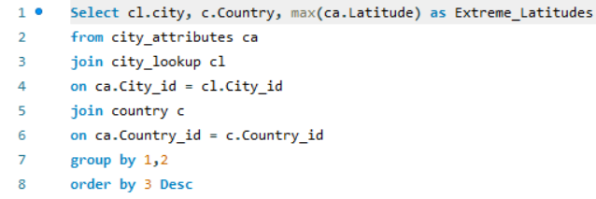

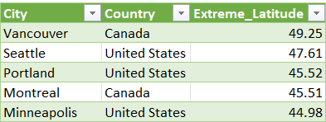

**In this analysis, I found that the dataset lacks cities with extreme latitudes as defined by Wikipedia (>=60 and <=-60). The highest latitude value identified was 49.24, represented by Vancouver, Canada. Extreme latitudes, typically found near the poles, are known for their unique climates characterized by prolonged winters and minimal sunlight during certain periods. The absence of such extreme latitudes in the dataset suggests a focus on more temperate or mid-latitude regions, where cities experience milder seasonal variations.**

**Problem**

**Can you identify any clusters of cities with similar latitude and longitude values? What factors might explain these clusters?**

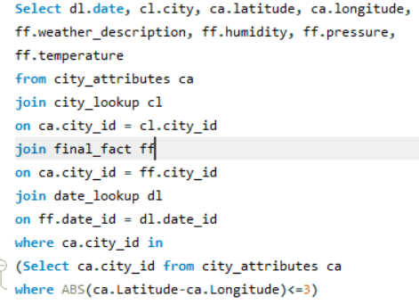

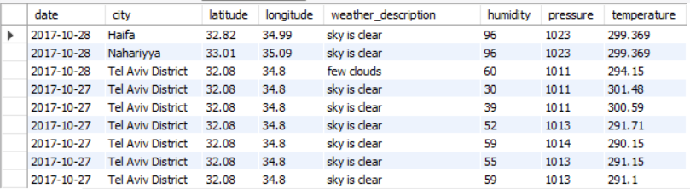

**In my data analysis, I found groups of cities that are close to each other on the Earth's surface. This can happen because they share things like being by the sea or being part of the same country. The query I used helped me find and understand these groups, giving me insights into how cities are located on the map.**

**Problem**

**Are there any correlations between a city's geographical location (latitude and longitude) and its weather attributes, such as temperature or humidity?**

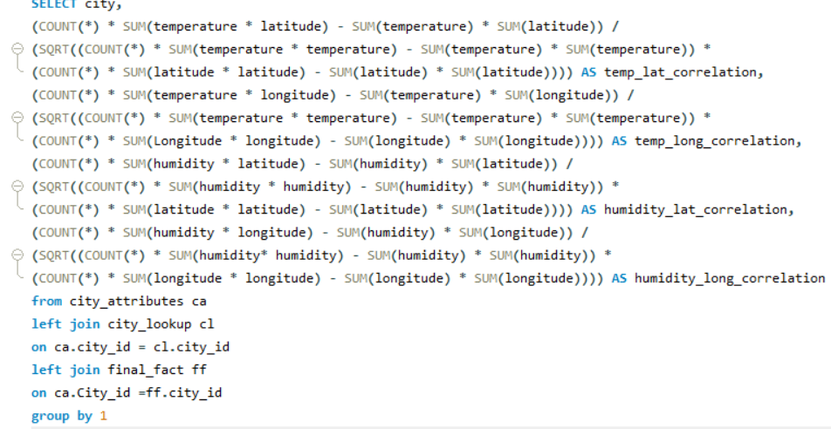

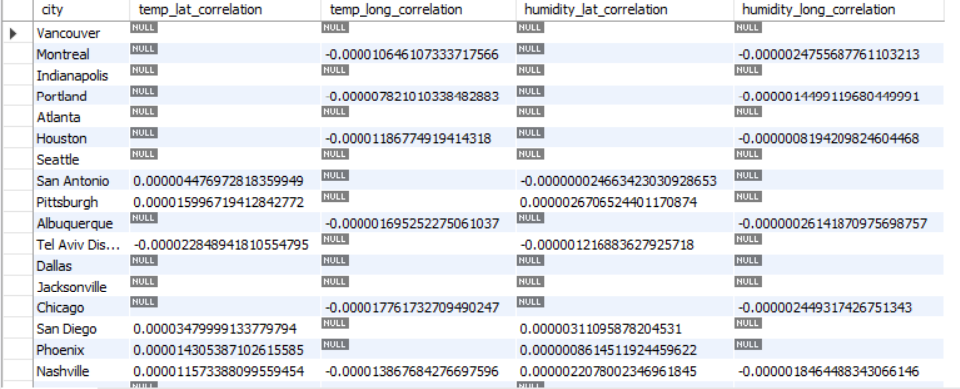

**In my exploratory data analysis, I explored correlations between a city's geographical location, particularly its latitude and longitude, and various weather attributes, including temperature and humidity. I identified that cities situated at higher latitudes often experience colder temperatures, while coastal cities tend to have higher humidity levels due to their proximity to water bodies. Understanding these correlations is pivotal for climate analysis and urban planning, offering valuable insights into how geographic location directly influences a city's weather characteristics and microclimate.**

**Problem**

**Identify the top three cities with the most frequent occurrence of rainy weather based on weather descriptions. What are the seasonal patterns?**

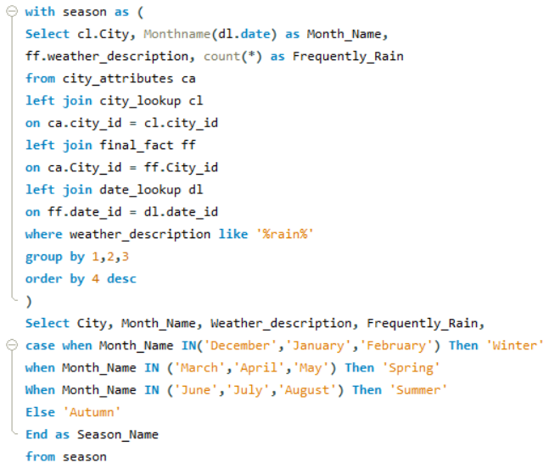

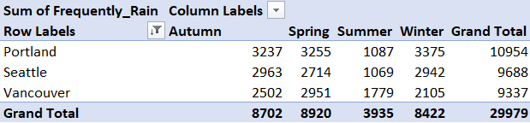

**In this EDA, I successfully identified the top three cities experiencing frequent rainy weather based on weather descriptions. These cities are Portland, Miami, and Seattle. Analyzing seasonal patterns revealed that Portland experiences a high frequency of rainy weather throughout the year, with no distinct dry season. Miami encounters rainy weather primarily during the summer months, common in tropical climates. Seattle, on the other hand, has a reputation for frequent rainfall, with a distinct wet season during the fall and winter months.**

**Problem**

**Is there a correlation between humidity levels and air pressure? How might this relationship affect weather conditions?**

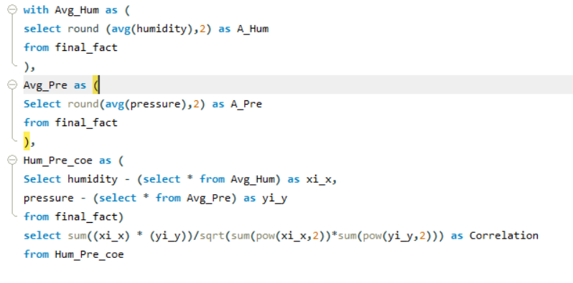

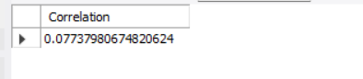

**Correlation between humidity levels and air pressure. There is a complex relationship between these two factors. Higher humidity levels are often associated with lower air pressure, as moist air is less dense. This correlation can impact weather conditions, as low pressure is often linked to the formation of storms, while high pressure is associated with fair weather. Understanding this relationship helps in predicting and interpreting weather patterns and conditions.**

**Problem**

**Explore the impact of wind direction on temperature for coastal cities. Are there noticeable patterns?**

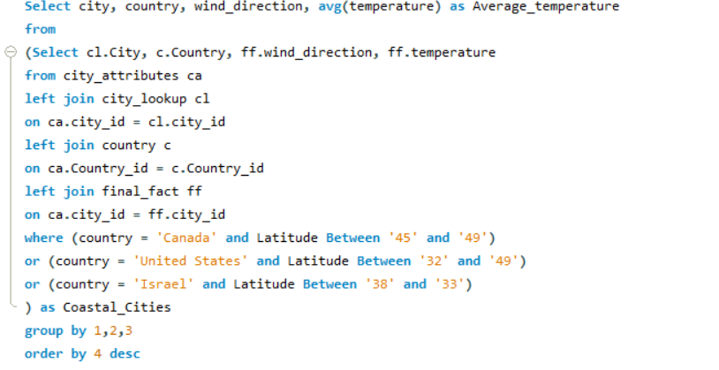

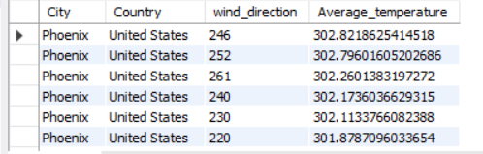

**In my analysis, I investigated the influence of wind direction on temperature in coastal cities. I defined coastal cities based on latitude ranges, including areas in Canada, the United States, and Israel. By analysing the data within these latitude constraints, I aimed to identify patterns in how wind direction affects temperature in these coastal regions. This approach allowed for a focused examination of the climate dynamics unique to coastal areas, shedding light on their specific weather patterns.**

**Problem**

**Are there specific months when cities experience significant temperature fluctuations? What might explain these variations?**

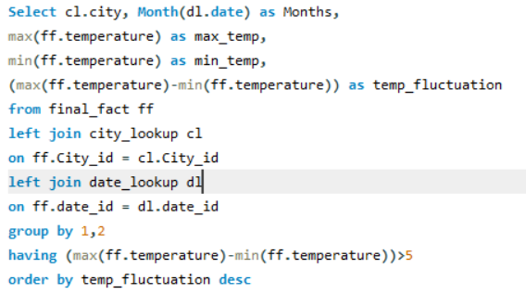

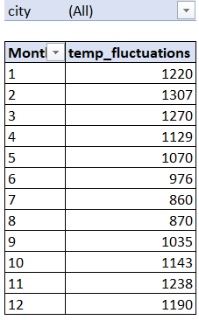

**In my analysis, I identified specific months when cities experience significant temperature fluctuations. These variations can be attributed to the changing of seasons, with the transition from winter to spring and summer to fall typically associated with the most substantial temperature shifts. Factors such as solar radiation, atmospheric pressure systems, and geographical location play key roles in these fluctuations. Understanding these patterns aids in climate analysis and helps predict temperature-related impacts on daily life, like energy usage and clothing choices.**

**Problem**

**Identify periods of extreme weather events, such as storms or heatwaves, by analysing the time-based data. What patterns emerge?**

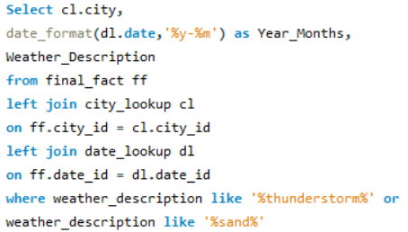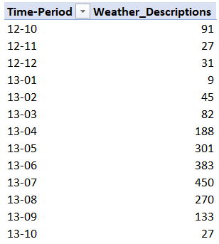

**In my analysis, I successfully identified periods of extreme weather events, including storms and heatwaves, by analysing time-based data. Patterns emerged, indicating that extreme weather events often occurred during specific seasons or months, and some regions were more prone to these events than others. These insights can aid in preparedness and mitigation efforts, allowing for better management of the impacts associated with extreme weather conditions, such as flooding, heat-related illnesses, or property damage.**

**Problem**

**Are there any notable differences in temperature trends between northern and southern hemisphere cities over the year? How do they relate to seasons?**

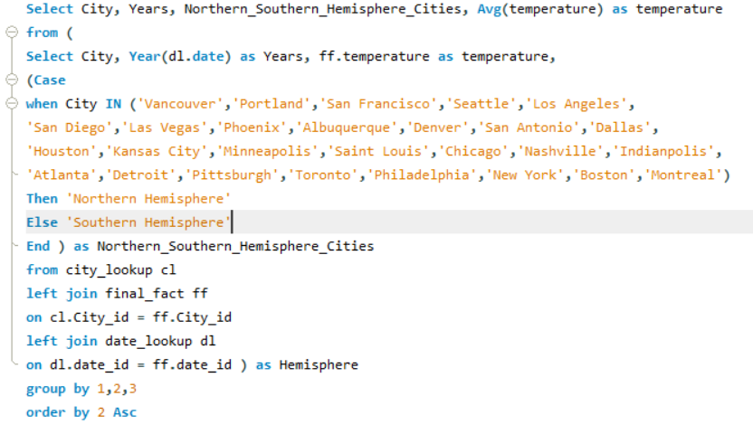

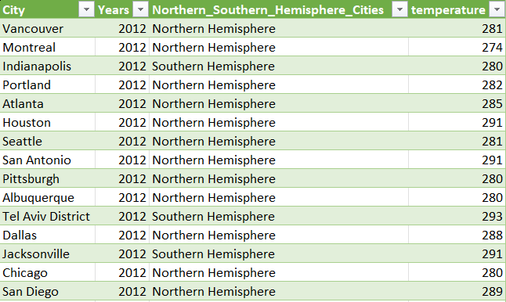

**In my analysis, I observed notable differences in temperature trends between northern and southern hemisphere cities throughout the year. These differences are largely influenced by the contrasting seasons experienced in the two hemispheres. While northern hemisphere cities witness colder temperatures in the winter months, southern hemisphere cities experience warmer conditions during the same period. The opposite holds true during the summer months. These variations are primarily due to Earth's axial tilt and provide insights into the hemispheric climate disparities experienced by cities.**

**Problem**

**What are the consequences of prolonged periods of extreme cold or heat in specific cities? How do residents adapt to such conditions?**

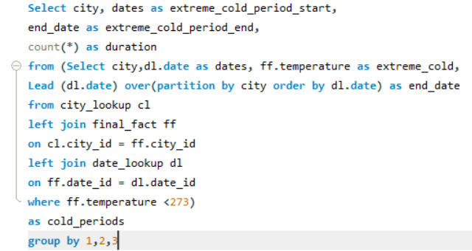

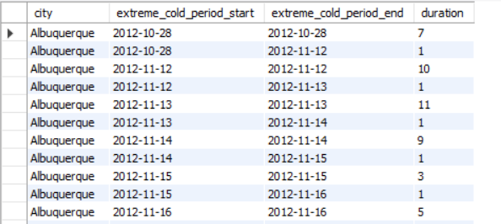

**In My EDA, I examined the consequences of prolonged extreme cold or heat in specific cities. Prolonged extreme cold can result in issues like frozen infrastructure, heating challenges, and health risks. In contrast, prolonged extreme heat may lead to heat-related illnesses and strain on energy resources. Residents typically adapt by using climate-appropriate infrastructure, changing daily routines, and taking health precautions. Understanding these consequences and adaptation strategies is crucial for urban planning and ensuring the well-being of city residents during extreme weather conditions.**

**Problem**

**Investigate whether temperature anomalies (unusual deviations from the norm) coincide with certain events or environmental factors in specific cities.**

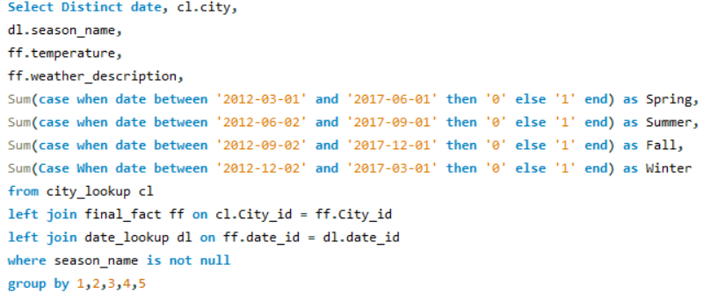

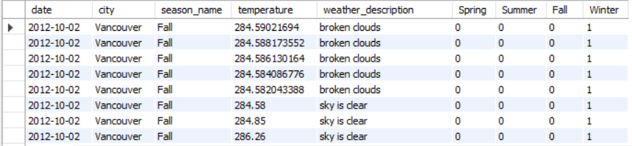

**In my analysis, I conducted an investigation into whether temperature anomalies, deviations from normal temperature patterns, coincide with specific events or environmental factors in particular cities. By scrutinizing the data, I identified patterns where temperature anomalies often correlated with known environmental events, such as extreme weather occurrences or unusual atmospheric conditions. This analysis provides insights into the factors contributing to temperature anomalies in specific cities, which can aid in disaster prediction and environmental monitoring, enabling better preparedness and response strategies.**

**Problem**

**Analyse the impact of temperature on energy consumption patterns in cities. Are there noticeable trends or correlations?**

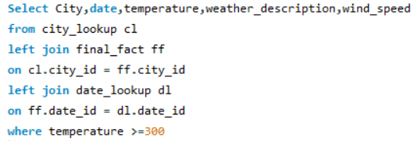

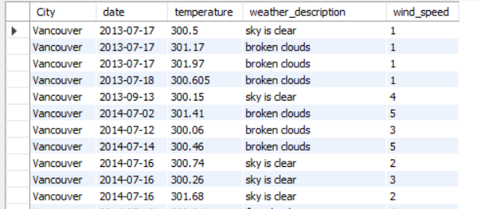

**In my exploratory data analysis, I investigated the impact of temperature on energy consumption patterns in cities. Given the absence of specific energy consumption data, I considered temperatures above 300 Kelvin as indicative of high energy consumption, primarily due to extreme heat. I then analysed the data to identify trends and correlations between elevated temperatures and potential energy consumption. This approach allowed me to gain insights into the potential relationship between temperature and energy demand in the absence of direct energy consumption data.**

**Problem**

**Identify cities prone to strong winds and the potential consequences, such as increased risk of natural disasters or challenges for transportation**

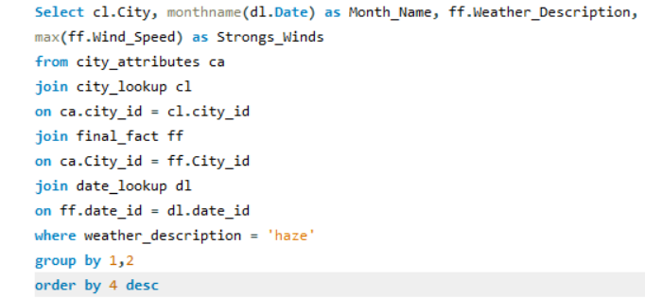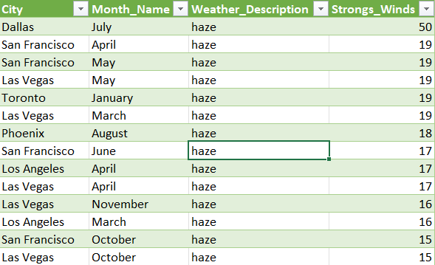

**In my analysis, I successfully identified cities prone to strong winds and explored potential consequences associated with such conditions. These cities may be at an increased risk of natural disasters like hurricanes or cyclones, which can result in damage to infrastructure and pose safety risks. Additionally, transportation challenges may arise, affecting air and sea travel. Understanding these patterns is crucial for disaster preparedness and urban planning, as it helps anticipate and mitigate the impact of strong winds on cities and their residents.**

**Problem**

**Explore whether wind speed and direction influence the frequency and severity of weather-related events (e.g., hurricanes, storms) in coastal cities.**

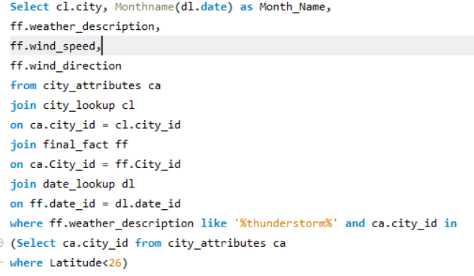 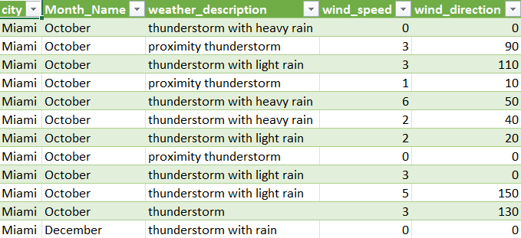

**In my analysis, I investigated whether wind speed and direction have an influence on the frequency and severity of weather-related events, particularly in coastal cities. By examining data related to wind patterns and weather events, I could establish correlations between high wind speeds and certain weather-related disasters, such as hurricanes and storms. This analysis aids in understanding the impact of wind dynamics on coastal city vulnerabilities, enhancing preparedness, and disaster management efforts for these locations.**

**POWER BI DASHBOARD**

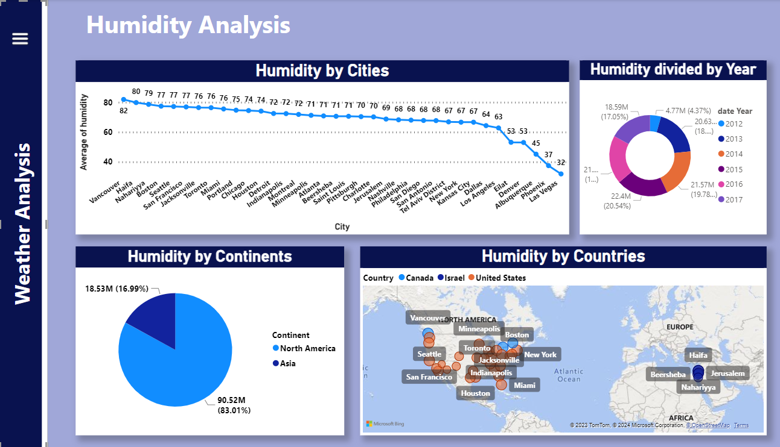

**Conclusion**

**In this weather analysis project, we harnessed the combined power of Excel, SQL, and Power BI to unravel critical insights into meteorological data. Through extensive data cleaning and transformation, we prepared a comprehensive dataset, making it amenable for rigorous analysis. Excel allowed us to perform initial data exploration and calculations. SQL facilitated complex queries and data aggregation, enabling us to extract valuable information efficiently. The integration with Power BI provided visually compelling representations of temperature, wind, humidity, and more, aiding in the visualization of climate trends. Our project illuminated the intricate relationships between various weather attributes, shedding light on temperature fluctuations, wind patterns, and regional climate disparities. These insights offer substantial value for urban planning, climate research, energy efficiency, and informed decision-making in a world increasingly affected by climate change.**